Rolling correlation: USDJPY and EURGBP
Method 05 / daily log returns / windows 20, 60, 100 / Low-value

Study setup
Logical pair: USDJPY , EURGBP
Broker symbols: USDJPY_i , EURGBP_i
Tier: Low-value (low_value)
Snapshot: 2026-11-03_majors_alpari_D1
Timeframe: D1
Matched return window: 1999-01-06 to 2026-11-02 (UTC bar dates)
Matched return count (rows before rolling): 7181
Dropped unfinished last bar dated 2026-11-03 UTC after a tick-volume check against the prior complete day.
Rolling windows W: 20, 60, 100 trading days
Live-shaped n for each score: n = W (not the full history length)
Complete matched rows (CSV): USDJPY-EURGBP_Rolling_D1.csv
Complete matched rows (HTML): USDJPY-EURGBP_Rolling_D1_data.html

Method carried forward
Rolling Pearson r is computed on matched daily log returns of close, ln(close_t / close_t-1), in the broker quote direction. Quotes are not inverted. For each day t with a full window, r_W uses the last W matched return pairs ending at t. That live-shaped sample size is W (20, 60, or 100), not the full multi-year history. The first W-1 days have no score. r is symmetric under swap of the two symbols. A high |r| in one window does not prove cause, lead-lag, or a trading signal. Short windows are noisier; long windows are slower to reflect a break.
How to read a live day: after both daily candles close, the newest r_20 uses the last 20 matched log returns, r_60 the last 60, and r_100 the last 100. Compare those three to each other and to the full-sample baseline below. A break is when the short window moves far from the baseline or flips sign while the baseline was meaningful.

Full-sample Pearson baseline (method 01 v001)
Copied full-sample Pearson r for USDJPY-EURGBP: -0.127992. This is a historical average link, not the live state.

Rolling results
W | latest_r | mean | median | min | max | std | pct_|r|>=0.4 | pct_|r|>=0.7 | n_roll
20 | 0.245513 | -0.101674 | -0.109123 | -0.862699 | 0.740234 | 0.282542 | 18.33 | 1.48 | 7162
60 | -0.086351 | -0.110038 | -0.101942 | -0.673603 | 0.551909 | 0.204123 | 9.88 | 0 | 7122
100 | 0.013357 | -0.113182 | -0.109591 | -0.571096 | 0.484691 | 0.183262 | 6.96 | 0 | 7082
n_roll is the number of days that had a complete window. pct_|r|>=0.4 and pct_|r|>=0.7 are the share of those days where the absolute rolling correlation cleared the threshold.

Conclusion
For USDJPY and EURGBP, full-sample Pearson baseline r=-0.1280. Latest rolling scores: r_20=0.2455, r_60=-0.0864, r_100=0.0134. Stability: short window is much noisier than the 100-day window. Agreement with baseline: r_20=0.246 opposite sign vs baseline; r_60=-0.086 near baseline; r_100=0.013 opposite sign vs baseline. Tier line: low interest — still near zero in recent windows. This is a monitoring summary, not a trade signal.

What to look at in this file next time
1) Latest r_20 vs r_60 vs r_100 in the results table. 2) Whether short-window latest has the same sign as the baseline. 3) The rolling chart for stretches where |r| collapsed. 4) The CSV if you need a different chart later.

Charts
Rolling Pearson r (20 / 60 / 100)
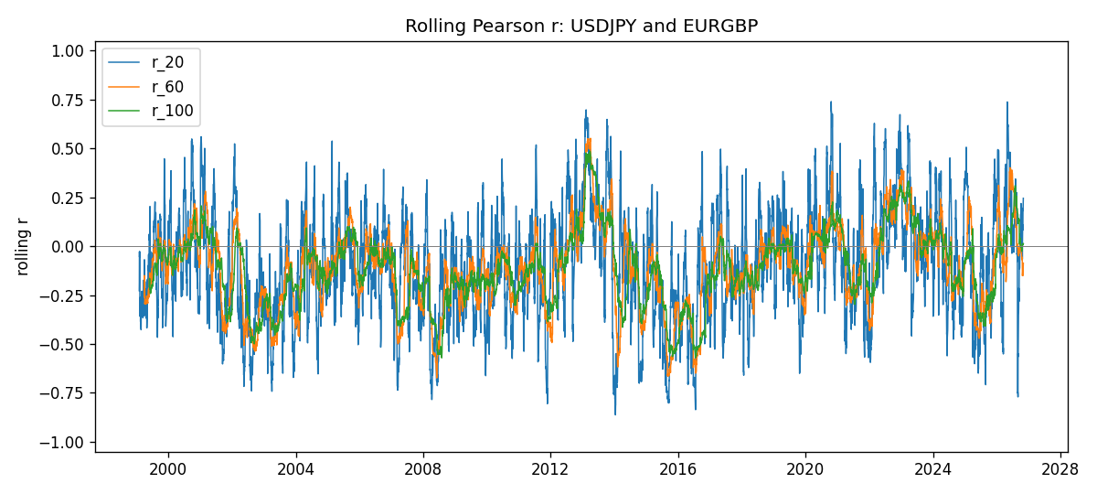
Daily closes

Daily log returns
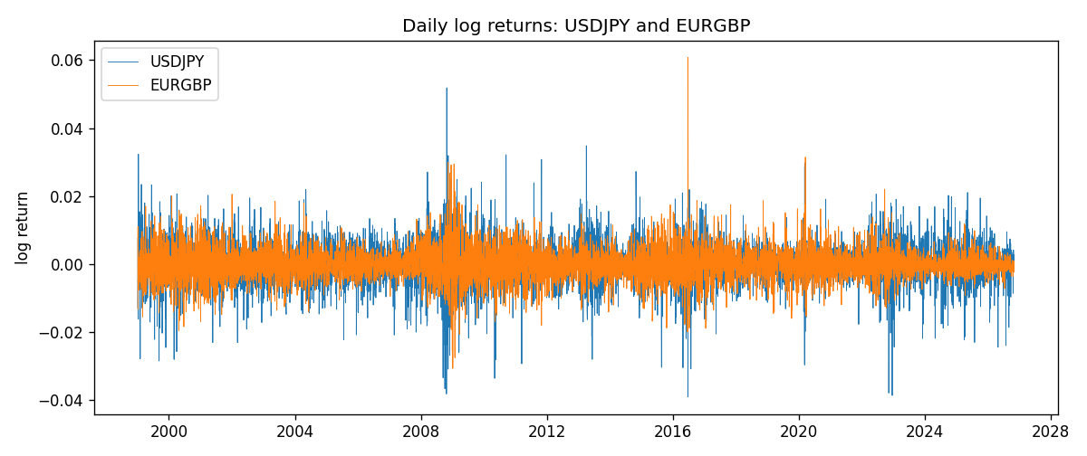

Data report
Every matched row with r_20, r_60, and r_100 is in the sibling CSV and HTML. This Word section holds column summaries and the first and last 15 rows of the rolling table.
Columns: time, USDJPY_close, EURGBP_close, USDJPY_tick_volume, EURGBP_tick_volume, USDJPY_log_return, EURGBP_log_return, r_20, r_60, r_100
Column summaries
column | count | mean | std | min | 25% | 50% | 75% | max
USDJPY_close | 7181 | 113.821 | 19.2443 | 75.811 | 104.38 | 111.015 | 120.695 | 163.851
EURGBP_close | 7181 | 0.787057 | 0.0966393 | 0.5735 | 0.6878 | 0.83401 | 0.86539 | 0.977
USDJPY_tick_volume | 7181 | 106399 | 179473 | 149 | 9958 | 53207 | 92916 | 1.80351e+06
EURGBP_tick_volume | 7181 | 87156 | 145514 | 154 | 6593 | 44384 | 81451 | 1.42468e+06
USDJPY_log_return | 7181 | 4.847e-05 | 0.00620794 | -0.039082 | -0.00320533 | 0.00011473 | 0.00340924 | 0.0518402
EURGBP_log_return | 7181 | 2.133e-05 | 0.00487349 | -0.0306737 | -0.00262366 | -0.00010035 | 0.00255918 | 0.0607539
r_20 | 7162 | -0.101674 | 0.282542 | -0.862699 | -0.298633 | -0.109123 | 0.0871176 | 0.740234
r_60 | 7122 | -0.110038 | 0.204123 | -0.673603 | -0.243295 | -0.101942 | 0.0176818 | 0.551909
r_100 | 7082 | -0.113182 | 0.183262 | -0.571096 | -0.222909 | -0.109591 | 0.00301584 | 0.484691
First 15 matched rows
time | USDJPY_close | EURGBP_close | USDJPY_log_return | EURGBP_log_return | r_20 | r_60 | r_100
1999-01-06 | 112.77 | 0.7019 | 0.00756602 | -0.0133033
1999-01-07 | 111.33 | 0.7097 | -0.0128516 | 0.0110514
1999-01-08 | 110.8 | 0.7062 | -0.00477199 | -0.00494386
1999-01-11 | 109.02 | 0.7053 | -0.0161954 | -0.00127524
1999-01-12 | 112.6 | 0.7077 | 0.0323104 | 0.00339703
1999-01-13 | 113.52 | 0.708 | 0.00813732 | 0.000423819
1999-01-14 | 113.52 | 0.7066 | 0 | -0.00197936
1999-01-15 | 114.15 | 0.7012 | 0.00553434 | -0.00767158
1999-01-18 | 114.16 | 0.7017 | 8.76002e-05 | 0.000712809
1999-01-19 | 113.52 | 0.7007 | -0.00562194 | -0.00142613
1999-01-20 | 112.91 | 0.7021 | -0.00538799 | 0.00199601
1999-01-21 | 113.87 | 0.7016 | 0.00846641 | -0.000712403
1999-01-22 | 114.56 | 0.7004 | 0.00604126 | -0.00171184
1999-01-25 | 113.72 | 0.6966 | -0.00735942 | -0.00544024
1999-01-26 | 113.86 | 0.6962 | 0.00123034 | -0.000574383
Last 15 matched rows
time | USDJPY_close | EURGBP_close | USDJPY_log_return | EURGBP_log_return | r_20 | r_60 | r_100
2026-10-13 | 158.305 | 0.84458 | -0.00189328 | 0.000201304 | 0.0289251 | -0.0530194 | -0.023753
2026-10-14 | 158.317 | 0.84553 | 7.58002e-05 | 0.00112419 | -0.0372746 | -0.05255 | -0.0257788
2026-10-15 | 158.024 | 0.84479 | -0.00185243 | -0.000875574 | 0.065467 | -0.066218 | -0.022636
2026-10-16 | 157.964 | 0.84307 | -0.000379761 | -0.00203808 | 0.148784 | -0.0654169 | -0.0218944
2026-10-19 | 158.517 | 0.84259 | 0.00349468 | -0.00056951 | 0.127293 | -0.06888 | -0.0177045
2026-10-20 | 158.16 | 0.83957 | -0.00225466 | -0.00359063 | 0.194802 | -0.0615457 | -0.00725048
2026-10-21 | 158.108 | 0.83839 | -0.000328835 | -0.00140647 | -0.00294644 | -0.0572973 | -0.00878652
2026-10-22 | 156.755 | 0.83682 | -0.00859427 | -0.00187439 | -0.0663807 | -0.128225 | 0.00682586
2026-10-23 | 156.81 | 0.83751 | 0.000350804 | 0.00082421 | 0.0198068 | -0.150646 | 0.00926026
2026-10-26 | 157.458 | 0.83762 | 0.00412387 | 0.000131333 | 0.110358 | -0.13277 | 0.0117707
2026-10-27 | 157.894 | 0.83595 | 0.00276517 | -0.00199573 | 0.0825707 | -0.147577 | 0.00883315
2026-10-28 | 157.743 | 0.83651 | -0.000956795 | 0.000669672 | 0.082799 | -0.150022 | 0.0070463
2026-10-29 | 157.683 | 0.83553 | -0.000380438 | -0.00117222 | 0.190186 | -0.140056 | 0.00948663
2026-10-30 | 157.516 | 0.83351 | -0.00105965 | -0.00242055 | 0.181221 | -0.131361 | 0.0112984
2026-11-02 | 157.933 | 0.83426 | 0.00264385 | 0.000899405 | 0.245513 | -0.0863512 | 0.0133566

